|  |  |
| --- | --- |
| CLIENT: WA State Dept of Health | PROJECT NAME: 988 Young Adult Campaign |

**Static Ads, Meta**

|  |  |
| --- | --- |
| **GRAPHIC COPY, BLACK/AA** | **GRAPHIC COPY, LGBTQIA2S+** |
| **When you feel alone**  We’re here to listen | **When you don’t know where to turn**  We’re here to listen |
| **META FEED COPY, BLACK/AA** | **META FEED COPY, LGBTQIA2S+** |
| **PRIMARY HEADLINE (125 characters):**  Hey, you matter. And if you need someone to listen, we’re always here. Just text, chat, or call 988.  **Headline (27 characters):**  988 is here for you 24/7/365 | **PRIMARY TEXT (125 characters):**  Hey, you matter. And it’s ok to need support. Text, chat, or call 988 any time you need someone to talk to.  **Headline (27 characters):**  988 is here for you 24/7/365 |

**GRAPHIC TO USE, BLACK/AA:** **LINK TO FILE**

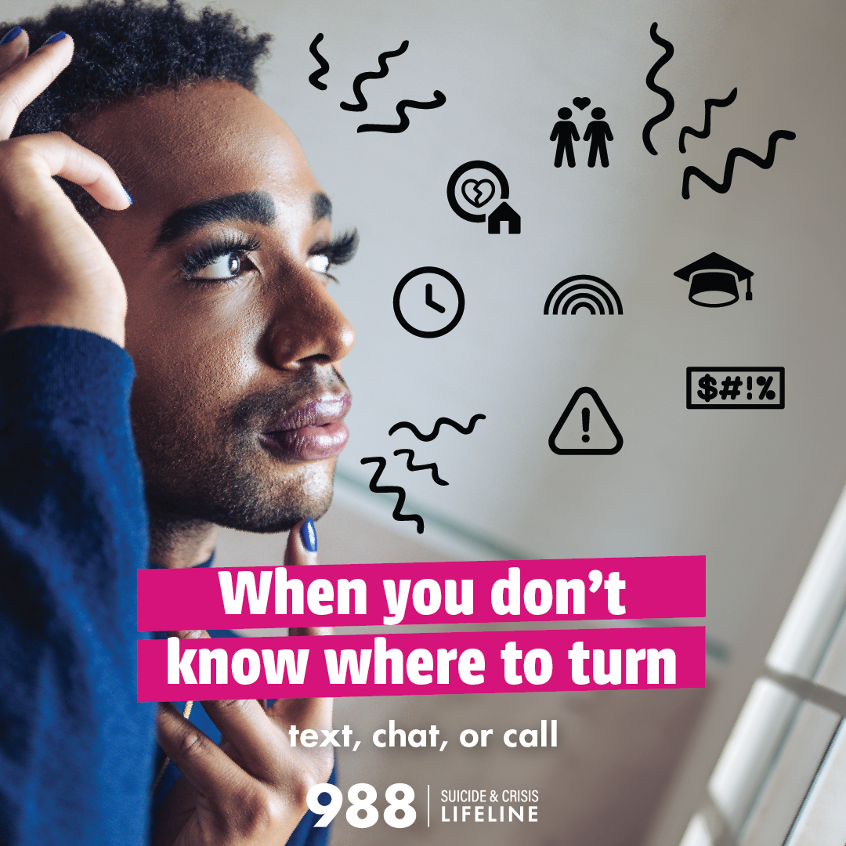

**GRAPHIC TO USE, LGBTQIA:** [**LINK TO FILE**](https://cplusc.box.com/s/mf0r24k3ub5aczp5dzrcldbhx57cw51m)

**Video Ads**

|  |  |
| --- | --- |
| **META, BLACK/AA** | **META, LGBTQIA2S+** |
| **PRIMARY TEXT (80 characters preferred):**  When you feel alone, you can count on 988. Text, chat, or call 988 to connect with a trained counselor.  **HEADLINE (27 characters):**  988 is here for you 24/7/365  **META VIDEOS – BLACK/AA (links to files below)**  [**Stories – 6 second version**](https://cplusc.box.com/s/stqej11chw0ydrdvs6ods81hgdgd27i1)  [**Stories – 15 second version**](https://cplusc.box.com/s/b0usn5t705uezlqoxa67a7u7ejyj5krq)  [**Reels – 6 second version**](https://cplusc.box.com/s/2pbzvxcimtgovg80sqlufp06hrh7t6ro)  [**Reels – 15 second version**](https://cplusc.box.com/s/15fit8ypjem405x6drrcz1gtvwhjscan) | **PRIMARY TEXT (125 characters):**  When you need support, you can count on 988. Text, chat, or call 988 to connect with a trained counselor.  **HEADLINE (27 characters):**  988 is here for you 24/7/365  **META VIDEOS – LGBTQIA (links to files below)**  [**Stories – 6 second version**](https://cplusc.box.com/s/tp77ohyfc3ozlcuqe0fddcdw79656spd)  [**Stories – 15 second version**](https://cplusc.box.com/s/ipa0sror7fcze4qv23c7ar6lvt0jak7f)  [**Reels – 6 second version**](https://cplusc.box.com/s/ttap72u1bys69uetiepqo4fi9qea932n)  [**Reels – 15 second version**](https://cplusc.box.com/s/vaxmcnzrnhhbaj8mb5f47429h48zbtzt) |