CLIENT: DOH 988 | PROJECT NAME: Older Adult Campaign

Static Ad

GRAPHIC IMAGE
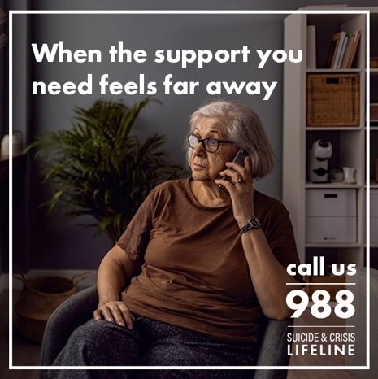
^ For general static post

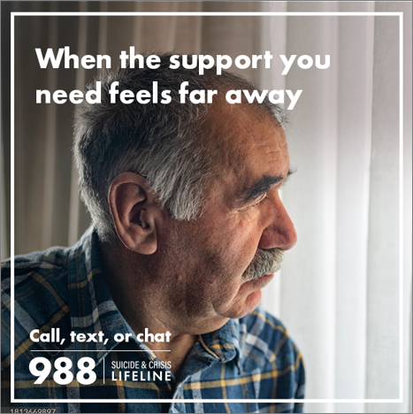
^ For hard of hearing static post

FACEBOOK FEED | INSTAGRAM FEED
- General  PRIMARY TEXT (125 characters):  Getting older isn’t all smiles and birthday parties. Sometimes you just need someone to talk to. Call 988, anytime, anywhere.  HEADLINE (25 characters):  988 is here for you  CTA BUTTON: Learn More  - Hard of Hearing  PRIMARY TEXT (125 characters):  988 is here for you. If you’re deaf or hard of hearing, call 988 Videophone or use your preferred TTY relay service  HEADLINE (25 characters):  988 by Videophone  CTA BUTTON: Learn More | Instagram copy same as Facebook

Video Ad

FACEBOOK FEED | INSTAGRAM FEED
- All 65+  PRIMARY TEXT (125 characters):  It’s not an easy thing getting older. Sometimes you just need a little help to deal with it all. Call 988 anytime, anywhere.  HEADLINE (25 characters):  988 is here for you  CTA BUTTON: Learn More  - Veterans  PRIMARY TEXT (125 characters):  It’s not easy getting older, especially for veterans. If you need help, a counselor is waiting. Just dial 988, press 1.  HEADLINE (25 characters):  988 is here for you  CTA BUTTON: Learn More | Instagram copy same as Facebook

